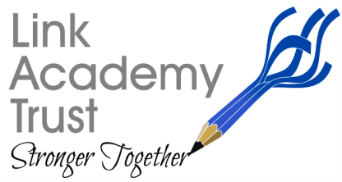
LINK ACADEMY TRUST
L a n d s c o v e S c h o o l H o u s e
L a n d s c o v e , Nr A s h b u r t o n
Devon. T Q 1 3 7 L Y
T e l : 0 1 8 0 3 7 6 2 1 1 3

January 8th 2021
Reminder
Dear parents and carers,

I have been speaking to all our Academy Heads today to see how things are progressing with online and blended learning. I am really pleased to say that academies are providing some excellent learning while also managing vulnerable and keyworker pupil’s learning in school. Where there have been glitches these are being overcome as successfully as possible. Obviously, our repertoire is still being extended and this will happen over time, so please have patience with us. We are determined to ensure quality-first teaching online throughout this lockdown to maintain pupil progress.
I am really proud of the children too, who have joined us, they are engaged and motivated and enjoying the experience of interacting and learning in this way with their friends. Parents are integral to this and I thank you as I know this is not easy- we will endeavour to make it as easy as possible though.
I would just like to remind parents that there are a few protocols we need to remind you of in order to keep children safe online.Supervision of pupils by an adult when they are online is paramount to ensure they remain on safe sites.
We, as a Trust are using Facebook to deliver the morning move session with Mr Tanner and his PE team, this site is designed for children that are 13 years and over, so we expect parents to access the site for their children and oversee them participating with this brilliant provision. We have chosen this route because many of our parents’ access what is happening in schools this way and are therefore familiar with it. We would also prefer that parents comment on the site rather than the children themselves- or at least endorse by making it clear in the message, i.e. my children have asked for a shout out for Widecombe primary. Given how many children enjoy this facility, which is incredible, please can you ensure you are using it safely in this way.
I would also like to take this opportunity to ask you to ensure everyone, parents and adults alike are appropriately dressed when online- pupils should be dressed and only in bedrooms if not in bed, similarly adults should have day-wear on.
We are hoping to give you all the opportunity to support us even further by providing a weekly online slot for parents to provide feedback on what has worked well, which enables us to share best practice across the Trust, while also giving critical support to ensure improvement. Thank you as always for your support.
Kind regards,
Nicky

Nicky Dunford, CEO The Link Academy Trust.

