Cheriton Bishop Primary School
History Curriculum Plan
At Cheriton, our history curriculum is a thoughtfully structured and progressive framework that supports high-quality teaching and learning across the school. Designed to meet the needs of our mixed-age classes, the curriculum is underpinned by key historical skills and concepts derived from the National Curriculum for History. These skills are carefully sequenced and allocated to individual year groups to ensure a coherent and cumulative learning journey.
We believe that the study of history should ignite curiosity and foster a deep passion for learning about the past. Through rich and engaging historical enquiries, all pupils explore how significant people, events, and developments have shaped the world we live in today. This understanding empowers them to become informed, reflective citizens who can contribute thoughtfully to the future.
Our curriculum promotes a strong foundation in chronological understanding, historical enquiry, and interpretation of evidence. Pupils are encouraged to think critically, evaluate sources, and appreciate the complexity of historical narratives. They learn to distinguish between fact and interpretation, consider multiple perspectives, and understand the significance of context in shaping historical accounts.
In line with our expectations for a broad and ambitious curriculum, our history provision is inclusive, diverse, and rooted in both local and global contexts. It is enriched through cross-curricular links, educational visits, and the use of artefacts and storytelling, ensuring that history is not only studied but experienced in meaningful and memorable ways.
Our History Curriculum is:
Aspirational
We set high expectations for history teaching and learning, nurturing children’s natural curiosity about the past. Our curriculum enables them to reach their full potential while appreciating the relevance and value of history in the 21st century.
Engaging
Our enquiry-based approach encourages children to ask thoughtful questions and investigate the past using historical sources. The second-order historical concepts—continuity & change, cause & consequence, similarity & difference, and significance—are embedded throughout, helping pupils understand how history is constructed and why interpretations may vary.
Logical, Broad, and Balanced
Our curriculum is carefully structured to include local, national, and global history, ensuring pupils develop a strong chronological framework. Learning sequences are designed to reflect the needs of our local community while aligning with the Early Years Foundation Stage (EYFS) and the National Curriculum.
Progressively Challenging
Children build on prior learning, encountering more complex historical knowledge and using increasingly sophisticated critical thinking skills. Key historical concepts—such as monarchy, invasion, and trade—are revisited and deepened throughout the curriculum. This approach enables children to develop a secure understanding of history as a discipline and what it means to ‘work historically.’
Inclusive
We believe that all children are entitled to access a rich and engaging history curriculum. Our teaching is carefully scaffolded, personalised, and differentiated to ensure that every child, regardless of ability or background, makes excellent progress in history.
The Cheriton Historian
By the time our pupils leave Cheriton, they will have:
A strong chronological knowledge, with a well-developed ‘mental timeline.’
A deep understanding of how historians construct interpretations of the past.
The ability to critically evaluate historical evidence and perspectives.
A sense of how the past has shaped the world today—and how their own actions can shape the future.
Our history curriculum ensures that every child at Cheriton develops the knowledge, skills, and curiosity to become a thoughtful, analytical, and informed historian.
Vocabulary
Children’s command of vocabulary is fundamental to learning and progress across the curriculum. Vocabulary is developed in each lesson actively, building systematically on pupil’s current knowledge and deepening their understanding of etymology and morphology (word origins and structures) to increase their store of words. Simultaneously, pupils make links between known and new vocabulary and discuss and apply shades of meaning. In this way, children expand the vocabulary choices that are available to them. It is essential to introduce technical vocabulary which define each curriculum subject. Vocabulary development is underpinned by an oracy culture and a tiered approach. High value is placed on the conscious, purposeful selection of well-chosen vocabulary and appropriate sentence structure to enrich access to learning and feed into written work across the curriculum.
Reception Vocabulary
Chronological vocabulary: childhood, future, great-grand parent, lifetime, living-memory, modern, month, past, present, tomorrow, week, year
Disciplinary Terms (Methods, Concepts, and Roles in Historical Study): cause, change, compare, consequence, continue, diary, evidence, history, impact, opinion, sequence, significance, similar, timeline
Substantive concepts: agriculture, belief, city, communication, education, explorer, government, inequality, invention, law, lifestyle, material, medicine, monarchy, occupation, power, religion, rights, society, technology, trade, transport, tradition
 | Autumn | Spring | Summer
Year B | Events: Harvest, Christmas, birthday,  The Little Red Hen.  Lifecycle of a hen.  Egg  Hatch  Chick  Feathers  Rooster  Hen  Nest  Incubate  Language of time – hour, day, week months. | Events : Easter  Dinosaur, fossils, evidence, Mary Anning, egg, bone, eat, prehistoric, extinct, habitat, skeleton, Stegosaurus, Tyrannosaurus Rex, Triceratops, Brachiosaurus, Velociraptor, Paleontologist, excavation, era, migration, past, present  Space Astronaut, moon, spaceshuttle, rocket, space suit, gravity, Neil Armstrong  Nocturnal Animals day and night  From Tadpole to frog Lifecycle of a frog Egg,Tadpole,Metamorphosis Gills,Froglet,Legs,Frog,Pond  Lost and found- Journey Expedition,Antarctica,Penguin, Colony, Iceberg, Waddle, Glacier, Climate  Events :Easter, Lent, | Dear Dinosaur  See Spring term  Bears don’t eat egg sandwiches – sandwich making sequence language  Sam Plants a Sunflower Life cycle of a sunflower. Seed, Germinate, Sprout, Stem, Leaf, Bloom, Petal, seedhead  The Ugly Vegetables  The Lighthouse Keepers Lunch – Grace Darling  Beacon,Tower,Lantern,Signal, Coastline, Navigation, Keeper Fog  Big Book of Bugs.

KS1 Key History Vocabulary
Chronological vocabulary: century, childhood, chronological, decade, future, great-grand parent, lifetime, living-memory, modern, month, period, recent, past, present, tomorrow, week, year
Disciplinary Terms (Methods, Concepts, and Roles in Historical Study): archaeologist, artefact, cause, change, compare, consequence, continue, diary, evidence, first-hand, historian, history, impact, interpretation, opinion, reason, second-hand, sequence, significance, similar, source, timeline, trustworthy, version
Substantive concepts: agriculture, architecture, belief, city, communication, conflict, democracy, education, empire, explorer, government, inequality, invasion, invention, law, lifestyle, manufacture, material, medicine, military, monarchy, occupation, power, protest, religion, rights, society, technology, trade, transport, tradition, war

 | Autumn | Spring | Summer
Year A | What does it take to become a Great Explorer? | Pompei: How do we know so much about where Sappho used to live? | Why is the history of my locality significant?
Year A | Substantive Vocabulary:  Mankind Merchant Mission Native Engineer Trade  Disciplinary Vocabulary:  Discover Expedition Explore Navigate Recruit Symbol  Remain Speech | Substantive Vocabulary:  Arena Artefacts Cathedral Century Emperor Empire Eruption Temple Villa Volcano Water Pump  Disciplinary Vocabulary :  Archaeologist Evidence Historian Preserved Primary Reconstruction  Secondary | Substantive Vocabulary :  British Empire Elizabethan Era Golden Hind Navy Sir Francis Drake Spain  Disciplinary Vocabulary :  Achievement Attack Reign Expedition Treasure
Year A | How do our favourite toys and games compare to those of the children of the 1960’s? | Who is the Greatest History Maker? | World War 1: Why was Charles sent to prison?
Year A | Substantive Terms: Electric Electronic Digital Internet Materials Metal, Plastic, Wood  Disciplinary Terms: Century. Childhood Lifetime. Living Memory Recent Safety | Disciplinary Terms Chronology Commemoration Discovery Evidence Plot Significant Timeline  Substantive Terms Executed Empire Expedition Event Kingdom Monarch Trade Willpower Religion Victory | Disciplinary Terms: Commemorate. Communication Crime Defence Punish Trade  Substantive Terms Enemy. Government. Memorial –. Patriotic Army Rationing Trench

Lower KS2 Key History Vocabulary
Chronological Vocabulary: AD, ancient, BC, era, generation, period, pre-history, millennium, million
Enquiry Vocabulary: anachronism, annotate, conclusion, consequence, effect, empathise, estimate, evidence, eye-witness, impact, monument, oral-history, primary evidence, reliable, representation, secondary evidence, significant, sources, summarise,
Substantive concepts: agriculture, architecture, civilisation, communication, conflict, conquest, currency, defence, economy, education, empire, exploration, folklore, inequality, innovation, invasion, invention, kingdom, law, lifestyle, manufacture, medicine, military, monarchy, peace, peasant, power, religion, resources, settlement, slavery, society, status, tax, technology, trade, transport, tribal, war, worship
 | Autumn Term | Spring Term | Summer Term
 | How did the arrival of the  Romans change Britain? | Who were the Anglo-Saxons and how do we know what was important to them? | What did the Vikings want in Britain?
 | Substantive Historical Vocabulary  Armour Battle Civilisation Empire Fort Rule Warrior  Weapons invasion  Disciplinary Historical Vocabulary  Evidence quotation | Substantive Historical Vocabulary  Anglo-Saxon Battle Christian Defences Nobleman  Settlement  Disciplinary Historical Vocabulary  Ceremonial Craftsmanship Plunder Ruin Trade | Substantive Historical Vocabulary  Battle Christianity Fortress Invasion Longships Vikings  Disciplinary Historical Vocabulary  Culture Defend Famine Settlement shield-wall Voyage
 | How did the lives of ancient Britons change during the stone age? | What is the secret of the standing stones?  (Bronze age) | How do artefacts help us to understand the  lives of the people in Iron Age Britain?
 | Substantive Historical Vocabulary  Agriculture Ancient Monument Neolithic New/Old Stone Age Settlement  Disciplinary Historical Vocabulary  Belief Ceremonial Excavation Reconstruction Remains  Ritual | Substantive Knowledge (Historical facts, concepts, and vocabulary)  Bronze Age, Artefacts, Cremated, Community, Status, Trade, Metalworking, Chamber, Monument, Memorial  Settlement  Disciplinary Knowledge  Discovery, Museum, Reconstruction , Speculate ,Analysis | Substantive Historical Vocabulary  Artefacts Barter Chariot Hill Fort Iron Age Tribe  Disciplinary Historical Vocabulary  Beliefs Customs Reconstruction Remains Siege Tools

Upper KS2 Key History Vocabulary – these are words to focus on ensuring the children have a deeper understanding.
Chronological Vocabulary: Anno Domini (AD), Before Christ (BC), Before Common Era (BCE), Common Era (CE)
Enquiry Vocabulary: authenticity, bias, causes, continuity, diversity, evaluate, factual, infer, interpret, interrogate, legacy, motive, primary source, reliability, represent, secondary source, significance, storyboard, synthesise, translation, viewpoint
Substantive concepts: agriculture, alliance, architecture, battle, belief, communication, conflict, culture, civilisation, colony, conquest, conservation, currency, defence, democracy, diversity, economy, education, empire, exploration, inequality, innovation, invasion, invention, folklore, lifestyle, manufacture, medicine, migration, military, monarchy, parliament, peasant, poverty, power, prejudice, protest, racism, religion, resistance, resources, revolt, settlement, slavery, society, status, strategy, tax, technology, tourism, trade, traditional, transport, tribal, strategy, war
Autumn 1st half |  | Spring 1st half | Summer 1st half
Year A | Why did Britain once rule the largest  empire the world has ever seen? | "To what extent was Sir Francis Drake’s role in the defeat of the Spanish Armada in 1588 crucial in shaping England’s position as a naval power?" |  | Why did the ancient Maya change  their way of life?
Year A | Substantive Historical Vocabulary  British Empire, Colonise, Colony, Dominance, Empire, Slave Labour  Disciplinary Historical Vocabulary  Allegiance, Convert, Independence, Moral, Rights, Transfer (of power) | Substantive Vocabulary  Privateer, Armada, Exploration, Colonialism ,Naval , Treaty ,  Disciplinary Vocabulary  Interpretation , Source , Bias Perspective , Chronology Significance |  | Substantive Historical Vocabulary  Defeat, Disease, Famine, Maya, Pyramid, Temple  Disciplinary Historical Vocabulary  Depict, Hieroglyphics, Labour, Nobility, Religious, Ritual
Year B | How did a pile of dragon bones help  to solve an ancient Chinese mystery? | Why was winning the ‘Battle of Britain’  in 1940 so important? |  | The story of the Trojan Horse:  historical fact legend or classical myth?
Year B | Substantive Historical Vocabulary  Ancestors  Civilisation  Emperor  Folklore  Monarch  Shang Dynasty  Disciplinary Historical Vocabulary  Advisers  Decipher  Govern  Hieroglyph  Illiterate  Translation | Substantive Historical Vocabulary  Aircraft Carrier  Battleship  Dunkirk  Evacuation  Invasion  Spitfire  Disciplinary Historical Vocabulary  Airborne  Artillery  Command  Diplomatic  Luftwaffe  Preparation |  | Substantive Historical Vocabulary  Battering Ram  Capture  Fortifications  Kingdoms  Sparta  Troy  Disciplinary Historical Vocabulary  Accuracy  Archaeological  Depiction  Evaluate  Evidence  Reliability

Curriculum Organisation and Information
Our History curriculum enables all learners to develop a historical perspective progressively as they move through each stage of their education, acquiring chronologically secure historical knowledge through historical enquiry. By using a history working wall and identifying the key chronology of each unit throughout each unit, our rolling programme embeds this understanding. Knowledge of people, events, and periods can only be meaningfully acquired when historical terms—such as key substantive concepts like ‘empire,’ ‘invasion,’ and ‘trade’—are taught in historical context and developed throughout the curriculum. The historical concepts of ‘continuity and change,’ ‘cause and consequence,’ ‘similarity and difference,’ and ‘significance’ underpin our enquiry-based learning. Children ask age-appropriate and increasingly nuanced questions, exploring how the past is constructed from a range of sources, appreciating why ‘interpretations’ of history vary, and, ultimately, understanding how knowledge of the past is constructed by historians.
The Early Years Foundation Stage (EYFS)
Children in Reception develop an early understanding of history through the knowledge and skills outlined in the EYFS area of learning called ‘Understanding of the World’ (UotW)—specifically ‘Past and Present.’ As with all learning in the early years, children’s understanding of the passing of time permeates all areas of the EYFS curriculum and is enriched through both specific teaching and broader classroom practices. Opportunities for extending understanding of the past and present are provided as appropriate, including spontaneous child-led learning moments.
Reception teachers plan engaging lessons linked to inspiring two week long topics to develop children’s historical knowledge, chronological understanding, and emergent enquiry skills. Lessons introduce topic-specific vocabulary, include both adult-led and play-based learning activities, and nurture the ‘characteristics of effective learning.’ Learning is embedded in the children’s real-life experiences, the experiences of people they know, and in the context of a wide variety of texts (stories, non-fiction, rhymes, and poems) shared in class.
Children explore the meaning of new vocabulary, use language to imagine and recreate roles in play situations, and learn to use past, present, and future terminology accurately. They learn to use tenses correctly, and, supported by our ‘Oracy’ approach, children develop their ability to clearly articulate their ideas and begin to justify their thinking. The language-rich learning environment is purposefully provisioned to further learning and provides opportunities for children to explore and compare aspects of the past with those of the present day. At all times, children are encouraged to be curious, observe closely, and discover for themselves—key skills that are fundamental to the development of our little historians.
Key Stage One and Two
Children in Key Stage One and Key Stage Two receive the full entitlement of the National Curriculum (NC). We ensure this is delivered through our enquiry-led history curriculum, based on the expertise of the Connected History units, which we have carefully crafted into a two-year rolling programme to meet the needs of our mixed-age classes. We have purposefully selected and sequenced topics across key stages to build cumulatively on prior learning and to progressively develop skills.
History learning is organised into half-termly topics (alternating with Geography), which allows students to ‘dive deeper’ into their learning, limiting the time between history topics, helping children to retain their knowledge. Opportunities for meaningful cross-curricular learning are provided whenever appropriate, particularly during half-terms when history is not being taught discretely, to revisit skills and reinforce key knowledge.
Our history topics are based around an engaging ‘big question’ (shaped by a second-order concept) that captures children’s interest and gives purpose to their learning. Rather than giving children all the answers, they embark on a journey of exploration! At the beginning of each topic, children share questions they would like to find answers to, and teachers encourage children to ask their own questions, understanding that curiosity is central to historical enquiry. Supported by our whole-school Oracy approach, children learn to articulate their ideas and justify their thinking. Opportunities for partner, group, and whole-class discussion and debate are planned into each topic. Studying history in this way inspires children’s curiosity, encourages them to ask critical questions, and develops their characteristics of effective learning.
Teachers use the Medium Term planning document to plan a sequence of learning based on their ‘big question’, referring to the Connected History guidance and the Progression in Key Skills document below and the historical terms banks above. Each topic has a clear learning journey, with an ‘elicitation task’ at the start of a topic to identify a child’s prior knowledge and a History cover page summarising key vocabulary and ‘big question’. Children are then taught the knowledge and skills they need to answer the over-arching ‘big question’ in small manageable steps, with each lesson having a clear curriculum linked learning objective which is shared with the children - making it clear what and how children are expected to learn. Teachers begin each lesson with a ‘flash-back’ to previous or key learning, to address misconceptions, reinforce learning and to support long-term memory connections – helping children retain knowledge. Lessons include a range of teaching approaches, activities are scaffolded and differentiated to challenge and support children appropriately and provide opportunities for children to work independently, with a partner or in a group. History lessons are tailored to the needs of each child, with teachers using ‘assessment for learning’ strategies to swiftly pinpoint children’s next steps in learning to identify those who require more support and those who can be challenged to ‘dig deeper’ - maximising progress. To ensure ‘key learning’ is embedded, teacher’s revisit ‘sticky knowledge’ regularly using knowledge organisers to support this. Learning is adapted and personalised to ensure children with SEND or EAL are able to access the full curriculum and have an equal opportunity to take part in every aspect of the History curriculum. A sway is used to document enrichment activities, assessment and scaffolding of assessments. A topic ends with a ‘time to shine’ activity which concludes and celebrates children’s learning.
Teachers promptly mark recorded learning in line with Cheriton’s marking policy, ensuring feedback is purposeful, furthering history learning and addressing misconceptions. Each classroom has a history working wall (which includes key vocabulary), book corners including topic-linked books and a timeline displayed to support children’s chronological understanding. Topics always include inspiring ‘hooks’ to provide memorable learning opportunities, with teachers organising trips to museums and cultural sites, guest speakers, immersion days, ICT and physical resources/artefacts are used where possible.
The subject leader monitors standards through ‘book looks’ including Tapestry, pupil conferencing, looking at planning, learning walks and discussions with staff and supports teachers with subject knowledge and continued professional development for example by leading staff meetings and making staff aware of new resources. Beyond curriculum specific learning the subject-lead also oversees the celebration and commemoration of annual significant and local historical events such as Armistice Day, Bonfire Night or the King Charles’ Coronation.
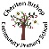 Connected Curriculum – Rolling Programme
EYFS | Yr A | Dear Zoo /People Who Help Us | The Little Red Hen / Brown Bear | Whatever Next / The Gingerbread Man | How to Catch a star/ Dinosaurs | Owl Babies /Goldilocks | Lost and Found /Tadpole to Frog | Dear Dinosaur | Bears Don’t eat sandwiches  Sam Plants a Sunflower/The Ugly Vegetables | The Lighthouse Keepers Lunch/Book of bugs
EYFS | Yr B | TBC
Key Stage One | Yr A | What does it take to become a Great Explorer?  ( Look at the first section on timelines from Year B Toys and complete the timeline activity) |  |  | Pompei: How do we know so much about where Sappho used to live? |  |  | Why is the history of my locality significant?  Sir Francis Drake
Key Stage One | Yr B | How do our favourite toys and games compare to those of the children of the 1960’s? |  |  | Who is the Greatest History Maker? |  |  | World War 1: Why was Charles sent to prison?
Lower Key Stage 2 | Yr A | How did the arrival of the  Romans change Britain? |  |  | Who were the Anglo-Saxons and how do we know what was important to them? |  |  | What did the Vikings want in Britain?
Lower Key Stage 2 | Yr B | How did the lives of ancient Britons change during the stone age? |  |  | What is the secret of the standing stones?  (Bronze age) |  |  | How do artefacts help us to understand the  lives of the people in Iron Age Britain?
Upper Key Stage 2 | Yr A | Why did Britain once rule the largest  empire the world has ever seen? |  |  | The story of the Trojan Horse:  historical fact legend or classical myth? |  |  | Local history
Upper Key Stage 2 | Yr B | How did a pile of dragon bones help  to solve an ancient Chinese mystery? |  |  | Why was winning the ‘Battle of Britain’  in 1940 so important? |  |  | Why did the ancient Maya change  their way of life?

The National Curriculum
Pupils are taught:
In Key Stage 1:
• changes within living memory. Where appropriate these should be used to reveal aspects of change in national life
• events beyond living memory that are significant nationally or globally [for example the Great Fire of London, the first aeroplane flight or events commemorated through festivals or anniversaries]
• the lives of significant individuals in the past who have contributed to national and international achievements. Some should be used to compare aspects of life in different periods
• Significant historical events, people and places in their own locality: Sir Francis Drake
In Key Stage 2:
• changes in Britain from the Stone Age to the Iron Age.
• the Roman Empire and its impact on Britain.
• Britain’s settlement by Anglo-Saxons and Scots.
• The Viking and Anglo-Saxon struggle for the Kingdom of England to the time of Edward the Confessor.
• a local history study – ‘Dartmoor’
• a study of an aspect or theme in British history that extends pupils’ chronological knowledge beyond 1066 – The Mayan Civilisation
• the achievements of the earliest civilizations – an overview of where and when the first civilizations appeared and a depth study of one of the following: Ancient Sumer; The Indus Valley; Ancient Egypt; The Shang Dynasty of Ancient China
• Ancient Greece – a study of Greek life and achievements and their influence on the western world
• a non-European society that provides contrasts with British history – one study chosen from: early Islamic civilization including a study of Baghdad c. AD 900; Mayan civilization c. AD 900; Benin (West Africa) c. AD 900-1300.
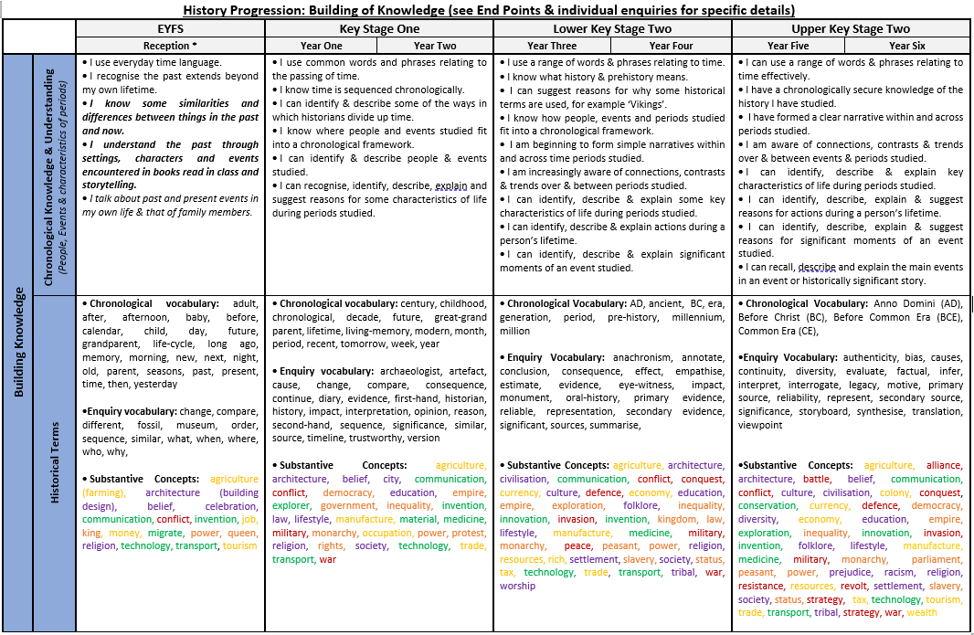
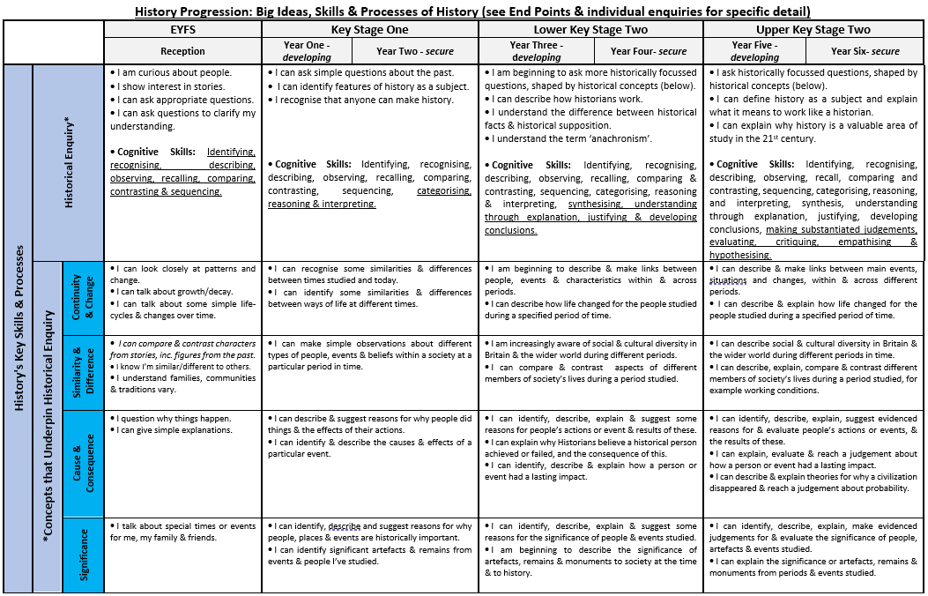
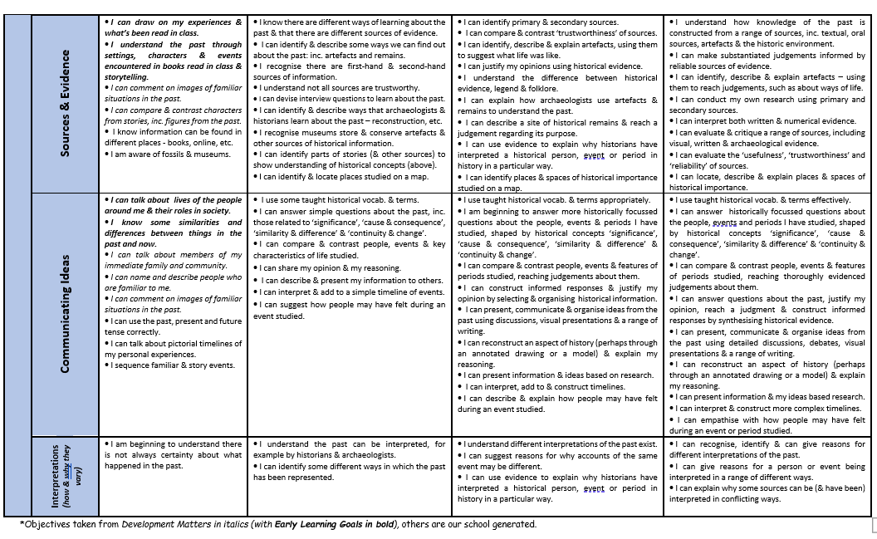
Assessment
In order to assess impact - a guide
Teachers are responsible for the regular assessment of their pupils against key knowledge and understanding to judge the impact of teaching and learning in History. Teachers look at the learning journey of each unit studied, being aware of what the children need for their next learning and what they can take from prior learning. Units will therefore begin with an elicitation task, either individual or whole class, to judge prior knowledge. A class assessment summary will be completed during the unit and used to inform future units of history learning. Each lesson will begin with a flashback of previously taught understanding to embed the key sticky knowledge they need to make through progress in their history learning.
Children’s progress is monitored against National Curriculum expectations and key skills. Judgement is informed through use of children’s books, dialogue, class scrapbooks, evidence on Tapestry. Teachers need to be clear on how the children will show their learning, through a presentation, art work or extended writing, for example, providing opportunity for pupils to communicate their learning in a variety of ways. Teachers use the assessment guidance provided within each Connected Curriculum unit to make informed judgements against the specific learning objectives and outcomes for that unit.

