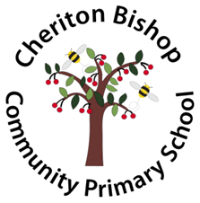
What is bullying?
Bullying is hurting someone several times, on purpose, by using behaviour or words which are meant to frighten or hurt that person.
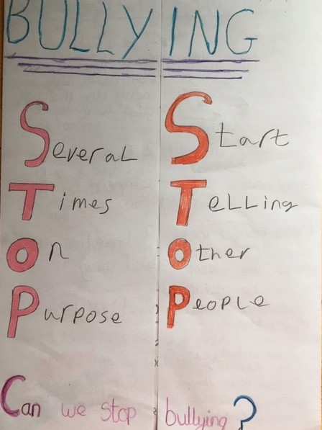

Be a buddy, not a bully
Everybody has the right to be
treated with respect.

Everybody has the right to
feel happy and safe.

No-one deserves to be a victim
of bullying.

Bullies need to learn
different ways of behaving.

If bullying happens, we will
help everyone to make it stop.

Bullying of any kind is unacceptable at our school.

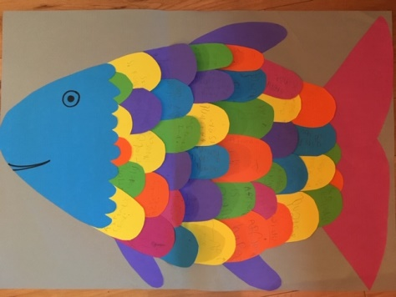
If you are being bullied:
DO
• Ask them to STOP if you can
• Ignore them
• Walk away and don’t get involved
• Get help
• TELL SOMEONE
DON’T
• Do what they say
• Get angry or look upset
• Hit them
• Think it’s your fault

Who can you tell?
• a teacher
• your parents or carers
• a friend
• another trusted adult
Don’t keep quiet or be embarrassed. Speak out!

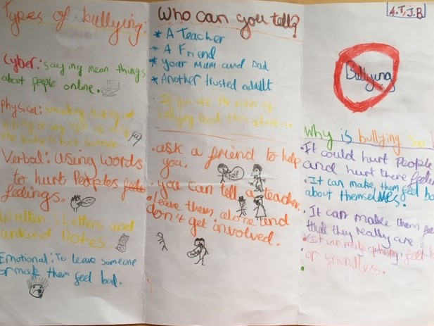

Some types of bullying:
• Emotional – hurting peoples’ feelings or leaving them out
• Verbal – name calling, teasing
• Physical – punching, kicking, spitting, pushing, punching, pulling hair
• Written – letters, notes, graffiti
• Cyber – sending unkind messages or emails, deleting friends from groups

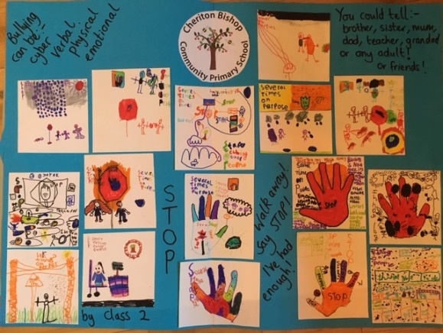
Where can you go if you don’t have anyone to play with?
• You can ask a teacher to help you find someone to play with
• You can go to the Buddy Bench on the playground and wait for a buddy or a teacher

Who can you call if you need help?
Childline: 0800 1111

