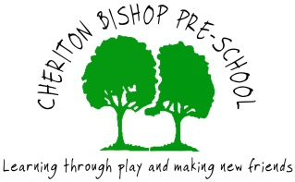
CHERITON BISHOP PRE-SCHOOL
NEWSLETTER 2nd HALF AUTUMN TERM

Our topic for this next half term will be – ‘Celebrations’. The children will all be exploring crafts and activities based around Bonfire Night, birthdays, Remembrance Day, Diwali, Christmas and the Nativity. Alongside this we will be taking opportunities to continue our ‘All about me’ topic, particularly looking at emotions whenever appropriate. We will also be focusing on encouraging & supporting teamwork activities, especially for the older children. Watch out for the weekly information email which will confirm the topic and main activities for that particular week.

AFTER SCHOOL WRAP AROUND CARE After the Autumn half term this will be available 5 days a week. Hopefully everyone will have received the email from school with information and booking form attached.
Charges £3.50 per hour. Booking forms are also available from the school office and Cheriton Bishop school website. Payments to be made in advance via parent pay. (We will not be able to confirm the place until we have received funds.)

SNACK DONATIONS – This is another request for snacks please for the next half term if you haven’t recently sent something in. Thank you very much for your support with this – if everyone can make one donation, we will then have plenty for the rest of the half term.

WHAT YOUR CHILD NEEDS TO BRING WITH THEM FOR EACH SESSION – everyone will need to wear warm clothes and an old coat that you won’t mind getting a bit painty! *We will be continuing to keep some windows open throughout the winter. Everyone will also need a named bag with a set of named spare clothes. All need a named drinks bottle and those having packed lunches will need a named packed lunch box, plus named containers. Also, a warm named coat, waterproofs for Tuesdays at the scout field and named wellies for every session. Wellies to be kept in a named plastic bag please which can be left at Preschool if not needed at home. Sorry to keep repeating above, but we are still having unnamed items being sent in each day.
Please do not send your child in with toys from home. We will continue with ‘Show & tell’ items via Tapestry which has been working well – you can share photos of a favourite toy or perhaps a family day out.

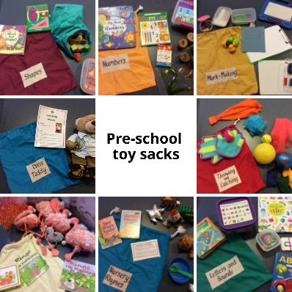
TOY SACKS AVAILABLE TO BORROW! As promised, here is some information around the toy sacks which will be available to book out from Monday 1st November.
The options are as follows-
‘Letters and sounds’
Throwing and catching
Dressing teddy
Numbers
Nursery rhymes
Shapes
‘Ringo the Flamingo’ story sack
Mark making
These sacks can be taken home on a weekly basis. Each sack includes an information sheet on different activity ideas and how that particular area of learning links with the new Early Years curriculum.
Any feedback on these would be very much appreciated and hopefully contents will be added to and improved on an ongoing basis.

CONTACT DETAILS - Pre-school landline – 24714 (Pre-school hours only) Mobile - 07977777318
Email – Christine.grist@thelink.academy

*Please speak to us if you have any suggestions, comments or concerns regarding Pre-school.

